**Chemistry Quiz #2 Total Marks: _____ / 26 [K/U]**

1. Fill in the table below **[3]**

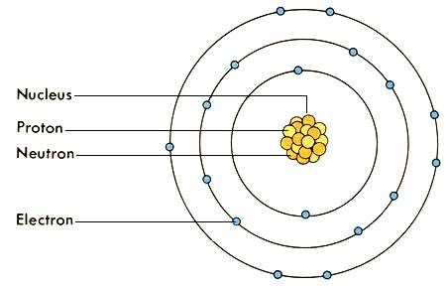

|  |  |  |
| --- | --- | --- |
| **Subatomic Particles** | **Overall**  **Charge** | **Location (Inside/ Outside of Nucleus)** |
| proton |  |  |
| neutron |  |  |
| electron |  |  |

1. Fill in the following table indicating whether element is a metal, non-metal or metalloid. **[2]**

|  |  |  |  |
| --- | --- | --- | --- |
| **Atomic  Number** | **Element  Symbol** | **Element Name** | **Metal / Non-metal / Metalloid** |
| 1 | H | Hydrogen | Non-metal |
| 3 |  |  |  |
| 9 |  |  |  |
| 11 |  |  |  |
| 17 |  |  |  |

1. Fill in the table below, indicating the number of protons, and electrons. Colour in the correct electrons for each Bohr-Rutherford diagram. **[12; 0.5 per blank]**

|  |  |  |  |  |  |  |
| --- | --- | --- | --- | --- | --- | --- |
| **Element  Symbol** | **Atomic  Number** | **Proton Number** | **Electron Number** | **Neutron Number** | **Standard Symbol** | **Diagram** |
| He |  |  |  |  |  |  |
| Mg |  |  |  |  |  |  |
| C |  |  |  |  |  |  |
| F |  |  |  |  |  |  |

1. Determine if each of the following substances are elements (E), compounds (c), homogenous mixtures (HOM) or heterogeneous mixtures (HET). **[6]**

Pizza _____

Carbon _____

Air _____

Pure Water (H2O) _____

Salt Water _____

Sand & Rocks _____

1. Draw a complete Bohr-Rutherford diagram for Sulphur (S) in the space below. **[3]**